ProCabinet
Database Visual Guide
Plain-English tour of the target schema
(after the pre-launch refactor)
Companion docs: SPEC.md (refactor spec), SCHEMA.md (the technical contract)

What this document is
This is a plain-English tour of the ProCabinet database — what each piece of data looks like, where it lives, and how the pieces connect. It’s the friendlier sibling to SCHEMA.md (the technical contract) and SPEC.md (the refactor plan).
Important framing: this describes the database as it will be after the pre-launch refactor. Today, the live database has only five tables, and a lot of what should be data lives inside browser storage. The refactor moves all of that into the cloud and unpacks the things that are currently stuffed together. So everything below is the destination, not the current state.

The big picture
Think of the database as your private workshop. Inside the workshop are sixteen labelled bins. Every customer, job, cabinet, sheet, edge band, quote, and order goes into exactly one of them. Nothing else uses your workshop — your data is invisible to other ProCabinet users.
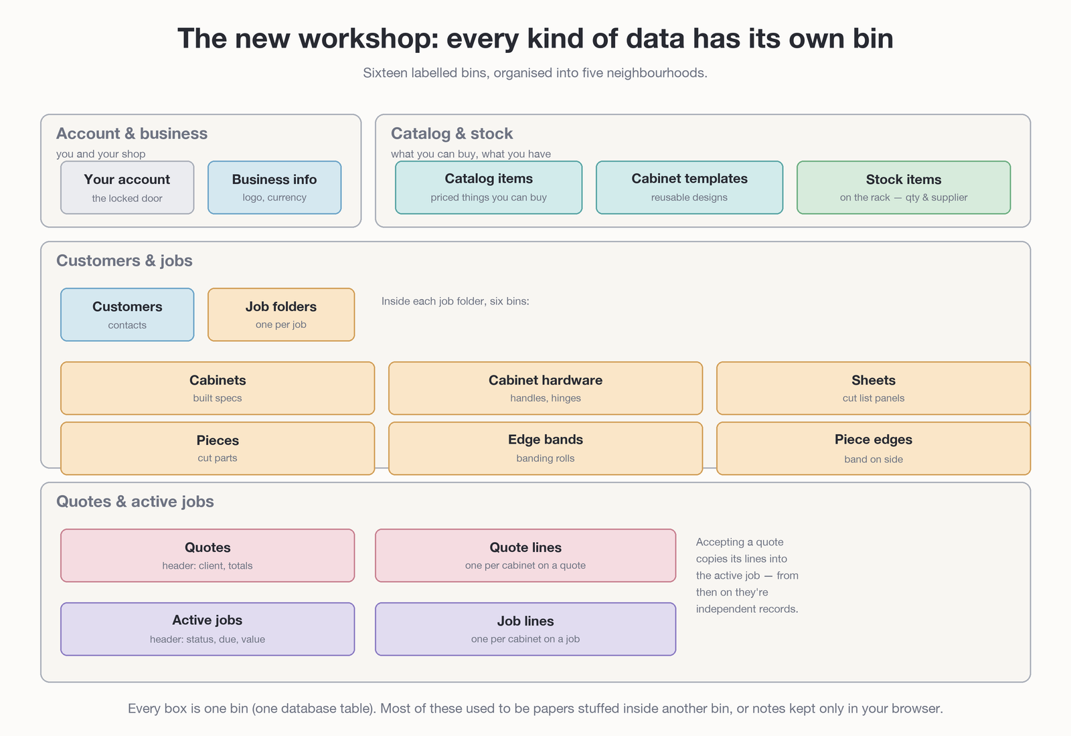
Figure 1. The full workshop after the refactor — sixteen bins in five neighbourhoods.
The neighbourhoods are:
- Account & business — your login, your company info.
- Catalog & stock — what you can buy/use (catalog), what designs you reuse (templates), and what you actually have on the rack (stock).
- Customers & jobs — your customers and the job folders you keep for each of them, plus everything inside those folders (cabinets, sheets, pieces, edge bands, etc.).
- Quotes & active jobs — priced quotes and the active jobs they turn into.

What’s changing
The current database has only five tables. The new one has sixteen. The difference isn’t random — it’s two specific shifts:
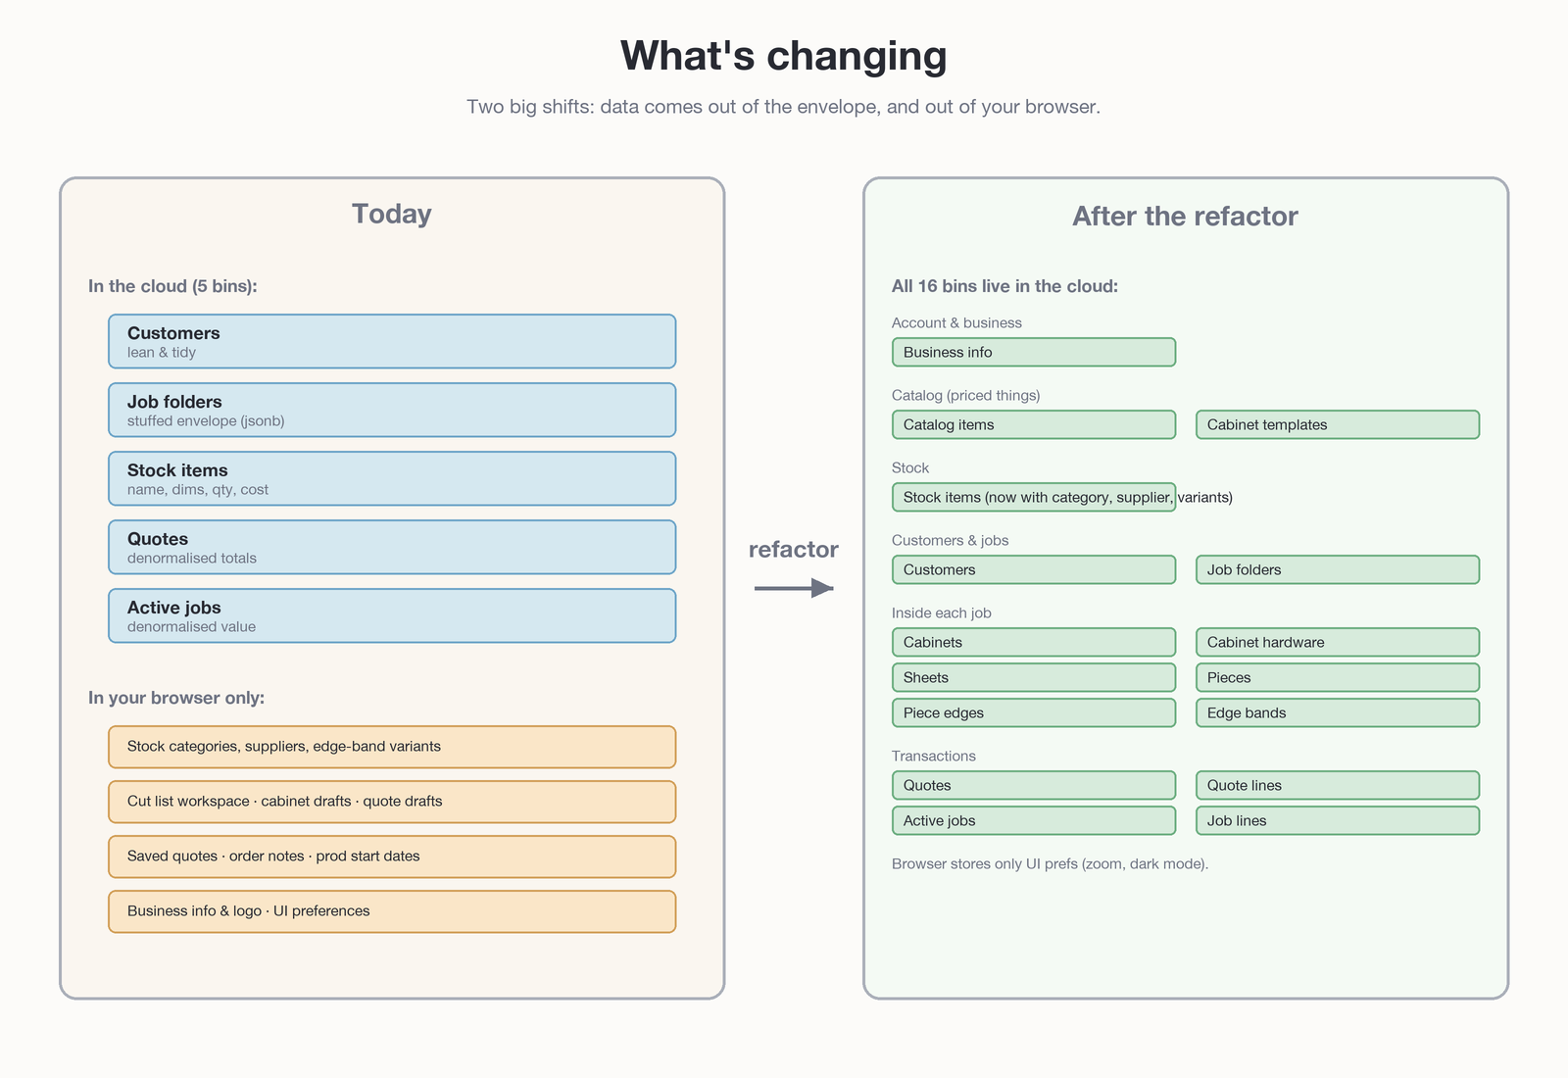
Figure 2. The today-vs-tomorrow comparison.

Shift 1: out of the envelope
Today, a job folder has a single field called data that is a flexible blob. Inside that blob lives everything to do with the job — cabinets, sheets, pieces, edge bands, layout settings, quote line items. It works, but the database can’t look inside the blob, so questions like “how much edge banding did I use this year?” are impossible to answer with SQL.
After the refactor, those things move into their own bins: cabinets, cabinet hardware, sheets, pieces, piece edges, edge bands. Each row knows which job folder it belongs to, but it’s a real first-class record — searchable, sortable, reportable.

Shift 2: out of the browser
Today, a surprising amount of data lives only inside whichever browser you happen to be using. Stock categories, suppliers, edge-band specs, draft quotes, business info, your logo — none of that travels when you sign in on a new computer.
After the refactor, all of that lives in the cloud. The browser keeps only true UI preferences: zoom level, dark mode, which columns are visible. Sign in anywhere and the workshop is whole.

How the bins connect
The bins aren’t random islands — most of them belong to something else. A cabinet belongs to a job folder. A job folder belongs to a customer. A piece edge connects a piece to an edge band. The full family tree:
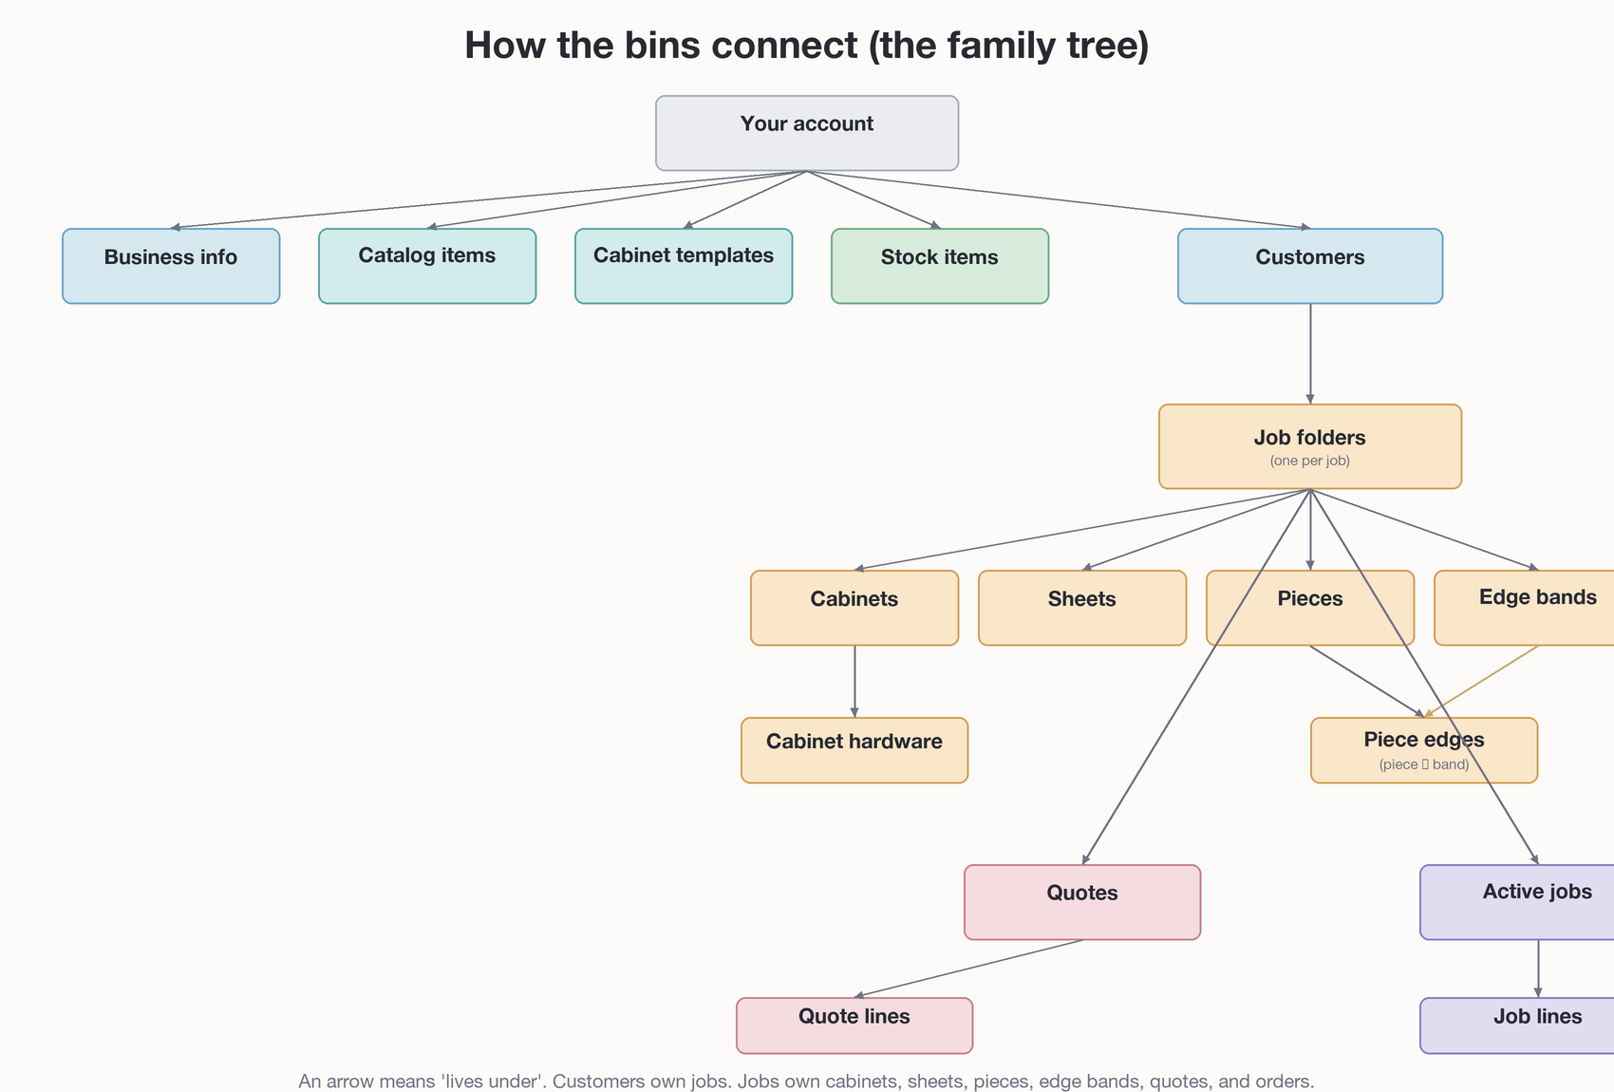
Figure 3. The family tree of the new schema.
Two patterns to notice:
- Most bins live under your account directly (catalog, templates, stock, customers, business info). These are shared across all your work.
- Job-specific bins (cabinets, sheets, pieces, edge bands, etc.) live under a job folder. Delete the folder and they go with it. That’s deliberate — they have no meaning without their job.
Piece edges is the one with two arrows pointing in. It’s a small junction bin: each row says “piece P has edge band B on side L1.” It connects pieces to edge bands without either of them having to know about the other directly.

The five neighbourhoods, explored

1. Account & business
Your account is what Supabase Auth manages — your email, your password, your session. You don’t edit this directly; signing up creates it.
Business info is one row per user: company name, phone, email, address, optional tax/business number, logo, default currency, default units (mm or inches). It’s the source for the header on every PDF you export.
Today this lives in the browser only. After the refactor it’s synced to your account, so logos and company details follow you between devices.

2. Catalog & stock
Three bins that sound similar but mean different things — this is the area most likely to confuse, so the diagram below makes it concrete:
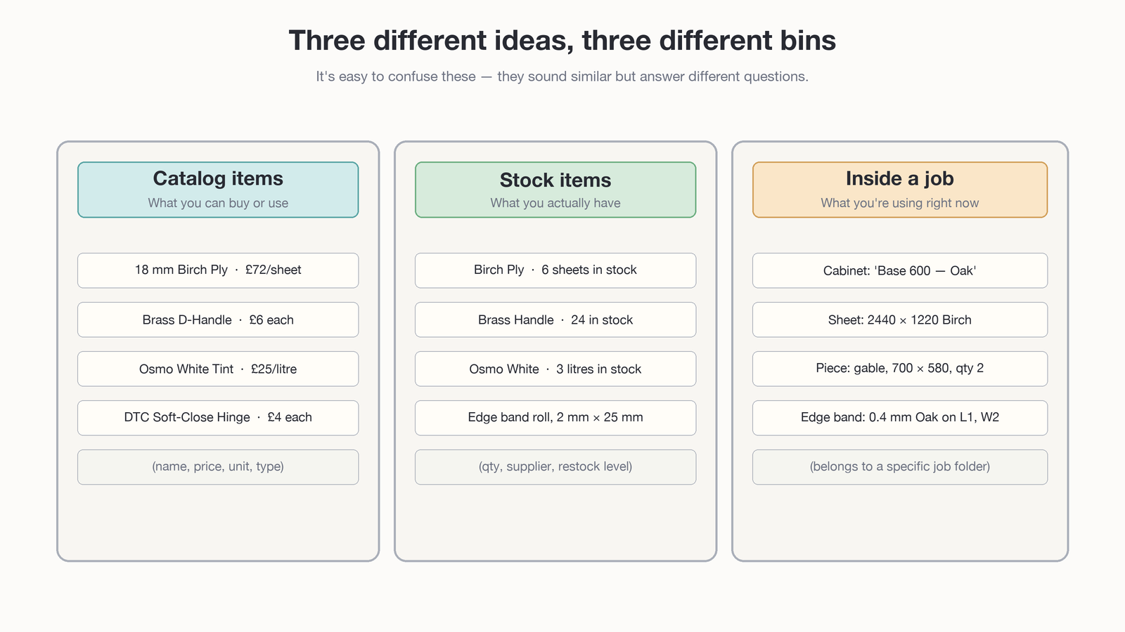
Figure 4. Catalog ≠ Stock ≠ Job. Same word, different ideas.
Catalog items is your priced library: this is what an 18 mm Birch Ply sheet costs, this is what a Brass D-Handle costs. One table holds all priced things — materials, handles, finishes, hardware — distinguished by a type field. The catalog is a reference, not an inventory.
Cabinet templates is reusable cabinet designs. When you create a “Base 600 Oak” template, every new project can start from it. They’re recipes, not actual cabinets.
Stock items is the inventory shelf — what you actually have on the rack right now: this many sheets, this many handles, this many metres of edge banding. Each item has a category (Sheet Goods, Edge Banding, Finishing, Hardware), a supplier, and reorder thresholds. Edge-banding stock additionally tracks thickness, width, length-on-the-roll, and glue type.
Catalog is what you can buy. Stock is what you have. A line item in a job is what you’re using. Three different concepts, three different bins.

3. Customers & their jobs
Customers is your address book — name, phone, email, address, notes. One line per customer, no design data, no prices.
Job folders is one row per job. Today the folder is mostly a manila envelope (the data jsonb blob). After the refactor it’s lean: just the basics (name, customer, dates) plus a small ui_prefs blob for zoom, column toggles, and similar visual settings. The actual content of the job moves into six dedicated bins underneath:
- Cabinets — built cabinets in this job, with full carcass spec (dimensions, materials, doors, drawers, shelves, base type, finish).
- Cabinet hardware — handles, hinges, runners, etc. attached to a specific cabinet.
- Sheets — the panels going through the cut list (size, kerf, grain direction, qty).
- Pieces — the cut parts (label, dimensions, qty, material reference, notes).
- Edge bands — banding rolls used on this job (thickness, width, length, glue, colour).
- Piece edges — a small junction table that says “piece P has edge band B on side S.” One row per banded edge.
All six are tied to a job folder. Delete the folder and they all go with it.

4. Quotes & active jobs
A quote is a priced offer to a customer. An active job is a confirmed quote that’s now moving through your production pipeline. Both have the same shape: a header row plus a set of line items.
- Quotes — the header: which customer, which project, markup percentage, tax percentage, status (draft / sent / accepted / declined / expired), date, notes, customer-facing reference number.
- Quote lines — one row per cabinet on the quote. Same kind of fields as a built cabinet (dimensions, materials, doors, drawers, shelves) plus pricing knobs (labour hours, overrides, hardware, extras).
- Active jobs — the order header: which customer, which project, status (confirmed / production / delivery / done / cancelled), due date, optional link back to the source quote.
- Job lines — same shape as quote lines, copied from the quote at the moment it was accepted.
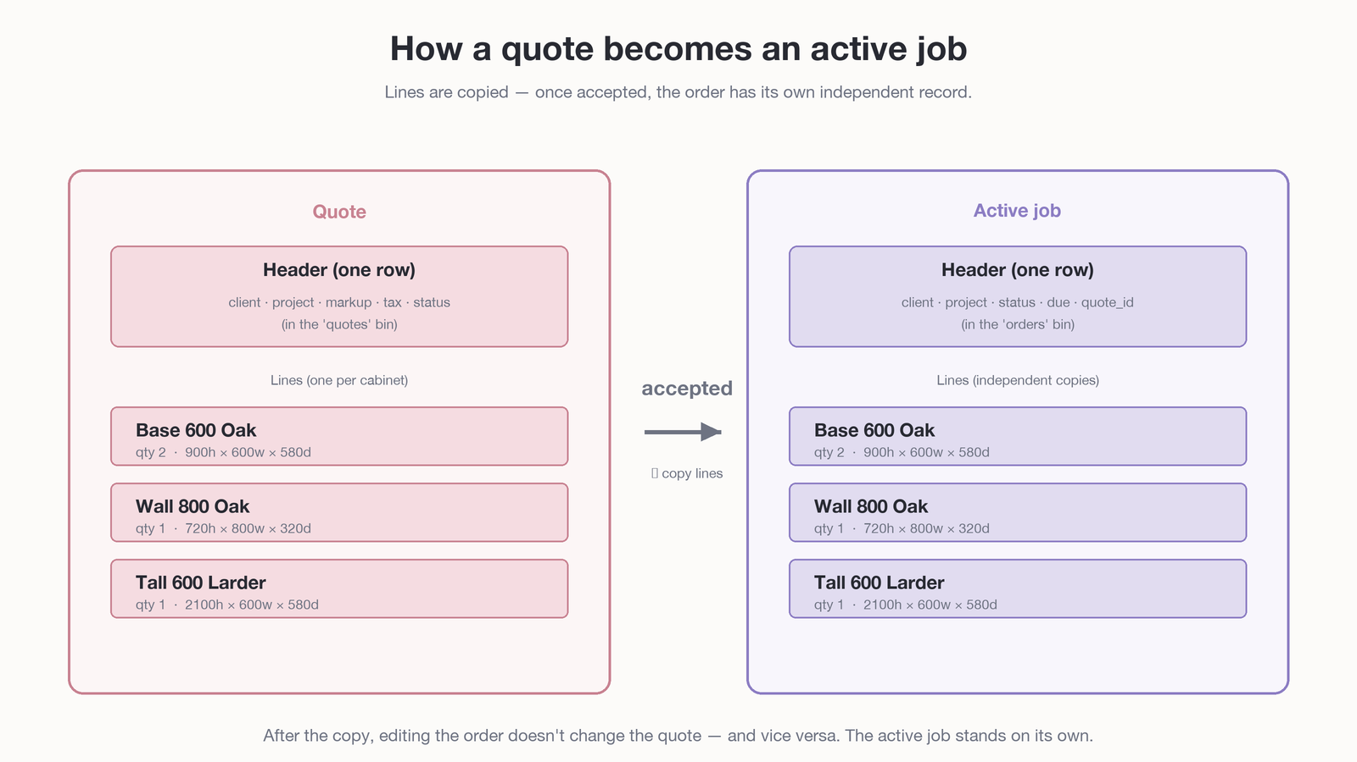
Figure 5. When a quote is accepted, its lines are copied into the active job.
The copy is intentional. Once a quote becomes a job, the two records are independent: editing the job doesn’t change the quote you sent the customer, and the customer’s accepted quote stays a record of what was agreed. The orders.quote_id column keeps a back-reference so you can always trace a job to the quote it came from.

The locked workshop door
Every row in every bin carries an invisible label saying which user owns it. The database enforces a single rule: when you log in, you only see rows with your label. Nobody else’s data is visible to you, and yours is invisible to them.
In database terms this is row-level security. In plain English: the workshop has a locked door, every user has their own key, and the lock can’t be picked from inside the app even if there’s a bug — the rule lives in the database itself.
A few bins (like piece edges) don’t carry the label directly. Instead, the database walks up the family tree: piece edges → pieces → job folder → customer → owner. As long as the chain leads back to your account, it’s yours.

Recap
- Sixteen bins, organised into five neighbourhoods: account & business; catalog & stock; customers & jobs; the six bins inside each job; quotes & active jobs.
- The two big shifts from today: data comes out of the “job folder envelope” into proper bins, and out of the browser into the cloud.
- Catalog ≠ Stock ≠ Job. Catalog is what you can buy. Stock is what you have. Job lines are what you’re using on a specific job.
- Cabinets and quote lines have nearly the same shape — a quote line is a cabinet you haven’t built yet.
- When a quote is accepted, its lines are copied into the active job. From then on the records are independent.
- Every row knows which user owns it. The database enforces it; the app can’t accidentally bypass the rule.

Where to go from here
This document is a tour, not a contract. For the precise schema with column types, foreign-key cascade rules, and RLS policies, see SCHEMA.md.
For the why-this-refactor-now reasoning and the phased rollout plan, see SPEC.md.
For the launch-level stack and progress tracking, see PLAN.md.

